
Design and Implementation of Course Prerequisite System
Using Topological Sort
Submitted in the partial fulfilment for the Course of
CSA0311- Data Structures
to the award of the degree of
BACHELOR OF TECHNOLOGY
IN
AIDS, AIML, IT
Submitted by
Deepika. P (192525026)
Nivedhitha. G (192521231)
Sharmila. M (192524395)
S Susmitha ( 192571068)
Under the Supervision of
Dr. M. Shikala
Saveetha School of engineering
Saveetha Institute of Medical and Technical Sciences
Chennai-602105
September 2026
COMMON COURSE ASSIGNMENT FORMAT
Particular | Details
Department: | Artificial intelligence & Machine learning
Programme: | B.Tech
Course Code & Course Name | CSA0311 Data Structure
Academic Year / Batch | 2nd year (2025-2029)
Faculty Name | Dr.M.Shakila
Assignment Title | Design and Implementation of Course Prerequisite System Using Topological Sort
Date of Issue | 31-08-2026
Date of Submission | 02-09-2026
Maximum Marks | 100
Course Outcome(s) – CO | CO2: Apply the suitable Abstract Data type for construction of the smart city emergency system  CO4: Make use of heaps, priority queue and hashing techniques for graph storage and route cache for repeated queries in C.  CO5: Develop robust smart city emergency system by implementing shortest path algorithms such as Dijkstra's algorithm, Floyd-Warshall.
Bloom's Taxonomy Level | L4 – Analyze
SDG Mapping (SDG 1-17) | SDG-9 and SDG-11
Industry / Societal Relevance | SDG 9 - Industry, Innovation, and Infrastructure SDG 11 – Sustainable Cities and Communities;

Problem Statement
University provides hundreds of courses from various departments and academic programmes. Some courses will require you to pass a course(s) before you can register. These prerequisites can be expressed as a directed graph, with nodes each representing a course, and a directed edge from node A to node B if B is a prerequisite for A.
For instance, a course of Data Structures must be taken first, and then Algorithms and after that, Machine Learning.
The proposed system is a directed graph of the whole course prerequisite graph and uses Topological Sort to produce a valid sequence of courses by which to take students. Both BFS-based Topological Sort using Kahn's Algorithm and DFS-based Topological Sort are implemented. The system is also able to detect cycles in the prerequisite graph. A cycle means that a student may not be able to enroll in the necessary courses because each course in the cycle requires another course from within the cycle that it also depends on. The working principles, complexity, advantages and limitations of BFS and DFS are compared and their suitability for a large-scale university course management system is discussed.
Objective
The main objectives of the proposed system are:
- To represent university courses and their prerequisites using a directed graph.
- To use an adjacency-list representation for efficient graph storage.
- To generate a valid course-taking order using Topological Sort.
- To implement Kahn's Algorithm using BFS.
- To implement DFS-based Topological Sort.
- To detect cycles in the prerequisite graph.
- To identify invalid or contradictory prerequisite relationships.
- To provide a semester-wise course planning approach.
- To compare BFS and DFS approaches based on time and space complexity.
- To determine the most suitable approach for a large-scale university course management system.

Requirements and Environment Used
Software | Requirement
Operating System | Windows 10/11
Programming Language | C
IDE | Visual Studio Code
Compiler | GCC
Data Structure | Directed Graph
Algorithms | BFS, DFS, Topological Sort
Testing | Command Prompt / VS Code Terminal

Proposed Solution
The University Course Planner that was proposed is Semester-wise University Course Planner using Graph Algorithms.
A directed graph is used, with one vertex for each course. There is a directed edge between two courses if one course is a prerequisite for another course.
Step 1 – Course Registration
The system stores the available courses.
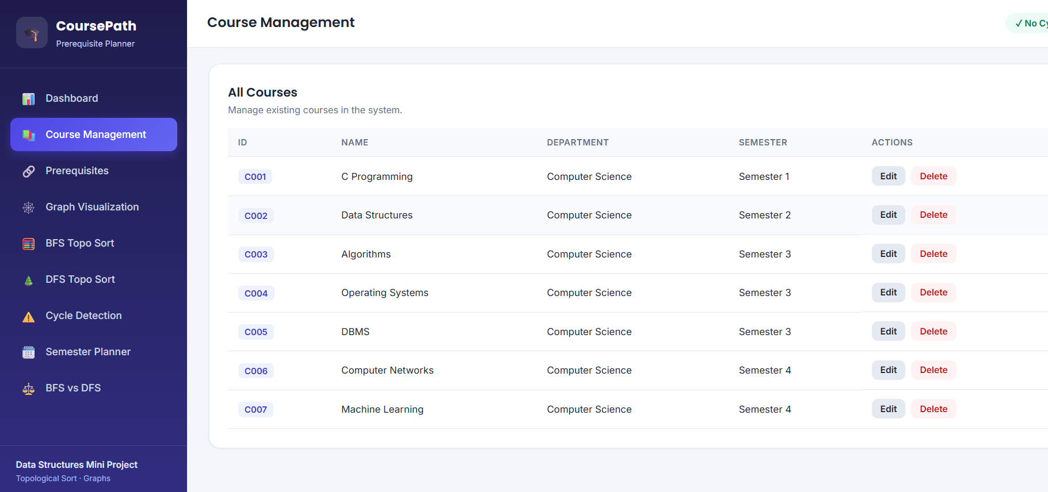
Step 2 – Prerequisite Mapping
Prerequisite relationships are represented as directed edges.
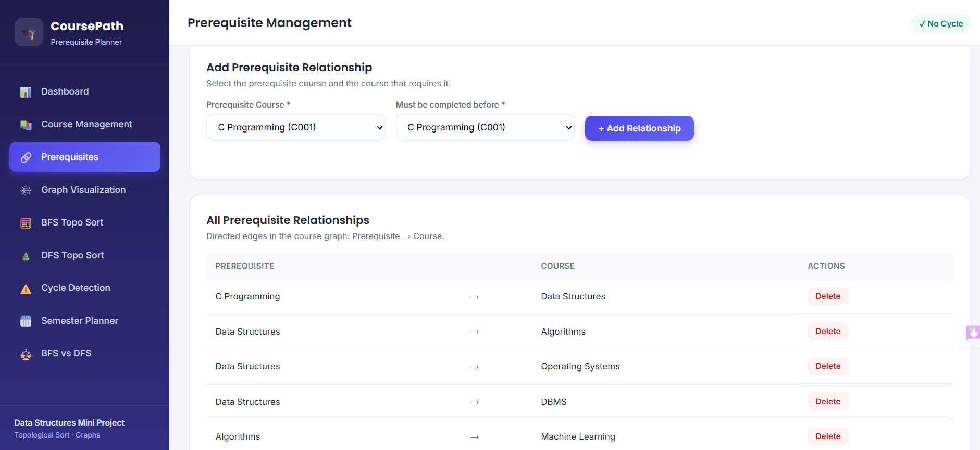
Step 3 – Graph Construction
An adjacency list is used to store the graph.
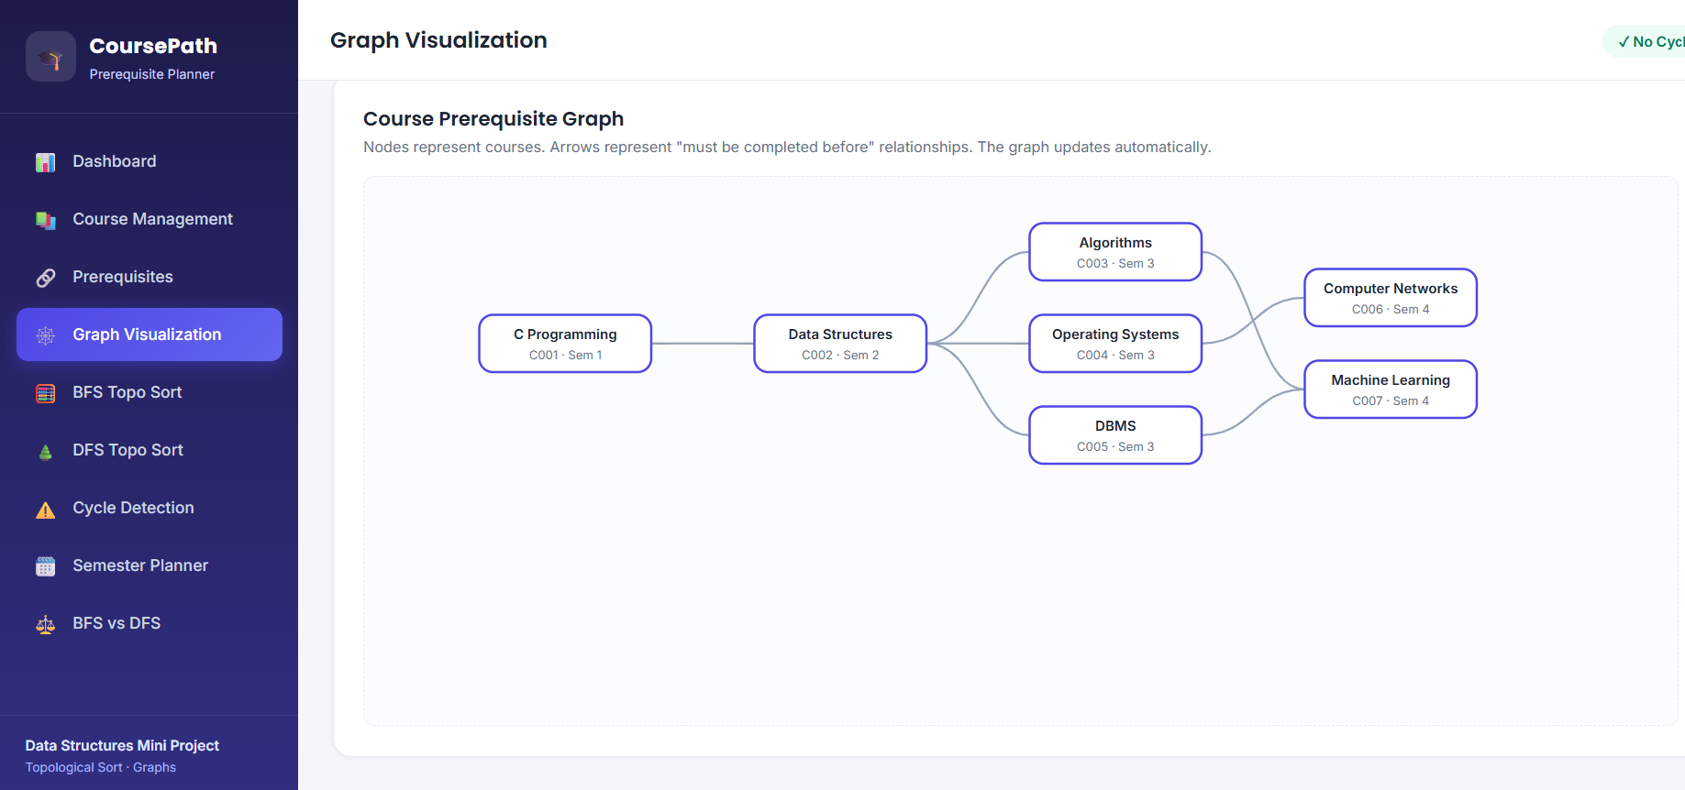
Step 4 – Cycle Detection
The system checks whether circular dependencies exist.
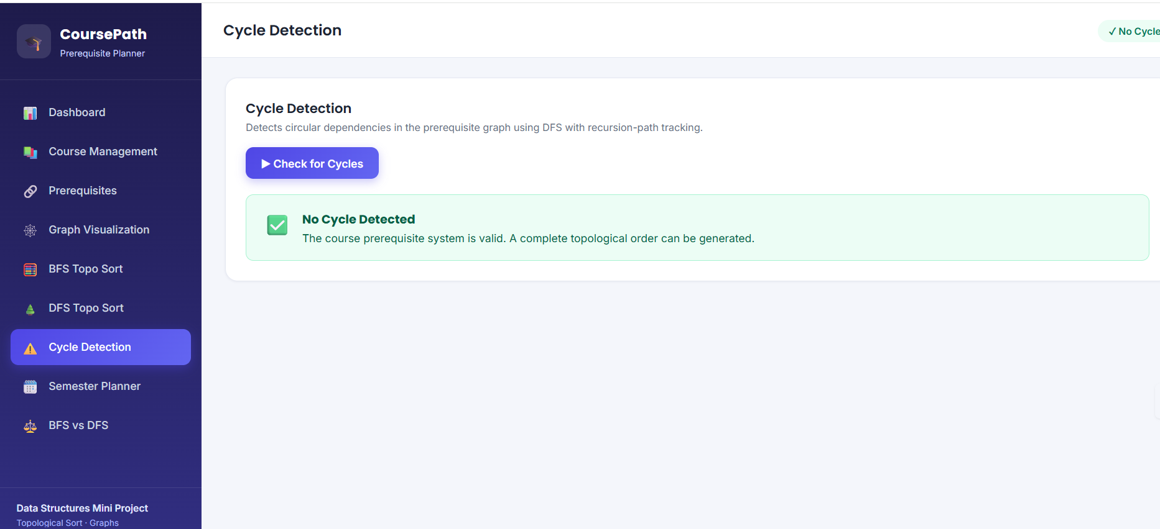
Step 5 – Topological Sorting
Both BFS and DFS approaches are applied to generate a valid course order.
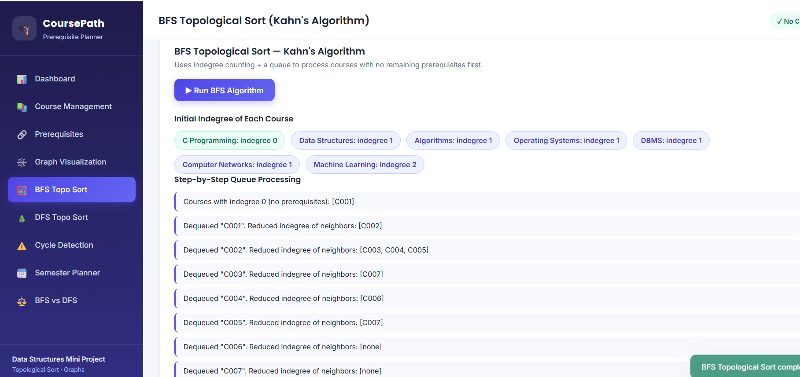
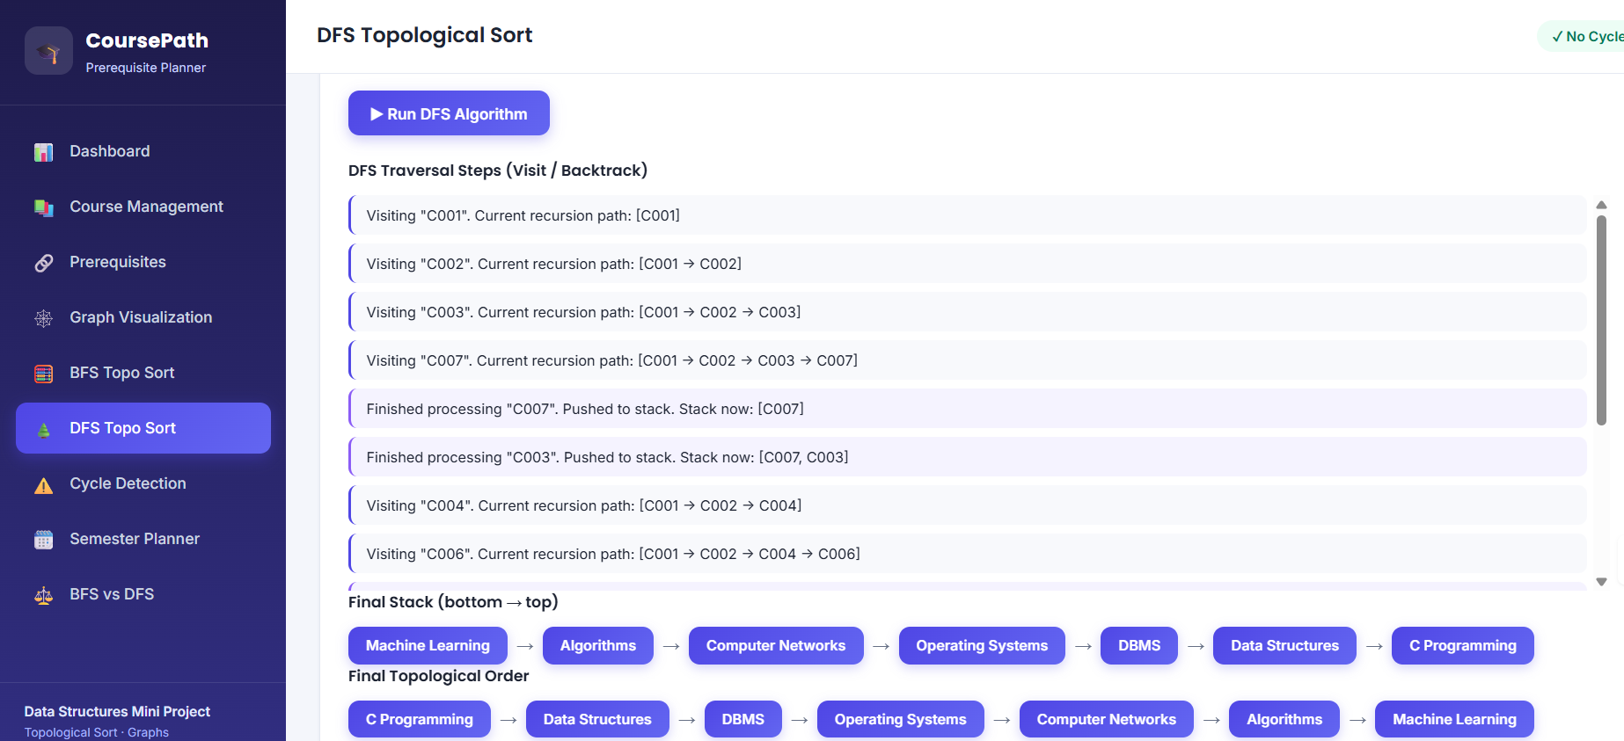
Step 6 – Semester-wise Planning
Courses with no remaining prerequisites can be considered for the current semester. After processing them, newly available courses can be assigned to subsequent semesters.
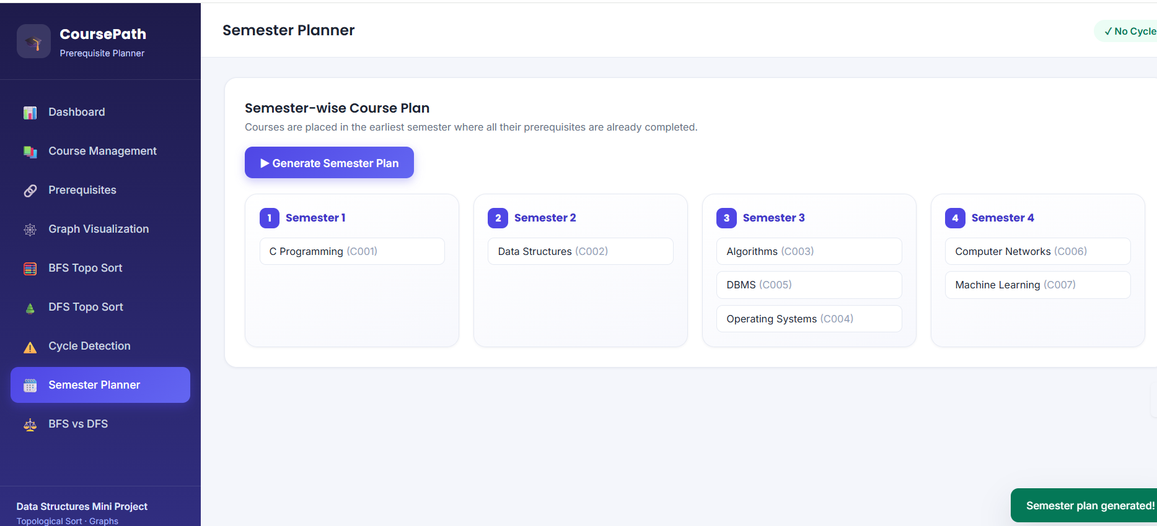

Algorithm
BFS-Based Topological Sort – Kahn's Algorithm
Algorithm
- Calculate the indegree of every course.
- Insert all courses having indegree 0 into a queue.
- Remove a course from the queue.
- Add the course to the result.
- Reduce the indegree of all courses dependent on it.
- If the indegree of a course becomes 0, add it to the queue.
- Repeat until the queue becomes empty.
- Compare the number of processed courses with the total number of courses.
- If all courses are processed, no cycle exists.
- Otherwise, a cycle exists.
KAHN_TOPOLOGICAL_SORT(Graph)

Calculate indegree of every course

Create an empty queue

For each course:
If indegree[course] == 0:
Insert course into queue

Create empty result

While queue is not empty:
course = Remove from queue
Add course to result

For each dependent course:
Decrease indegree by 1

If indegree becomes 0:
Insert course into queue

If number of processed courses < total courses:
Display "Cycle detected"
Else:
Display valid course order

DFS-Based Topological Sort
Algorithm
- Initially mark all courses as unvisited.
- Select an unvisited course.
- Mark it as currently visiting.
- Visit all courses dependent on it.
- If a currently visiting course is encountered again, a cycle exists.
- After all dependent courses are completed, mark the course as visited.
- Push the course into a stack.
- Reverse the stack to obtain the topological order.
Pseudocode
DFS(course)

Mark course as VISITING

For each dependent course:
If dependent course is VISITING:
Cycle detected

If dependent course is NOT VISITED:
DFS(dependent course)

Mark course as COMPLETED

Push course into stack
Algorithm comparision
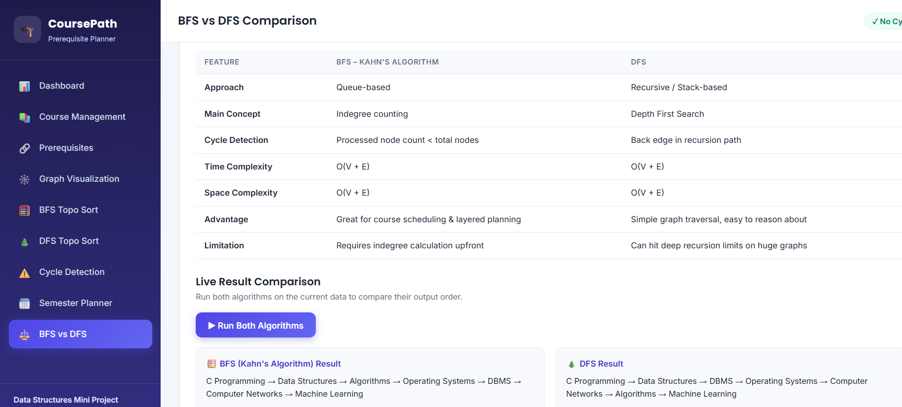
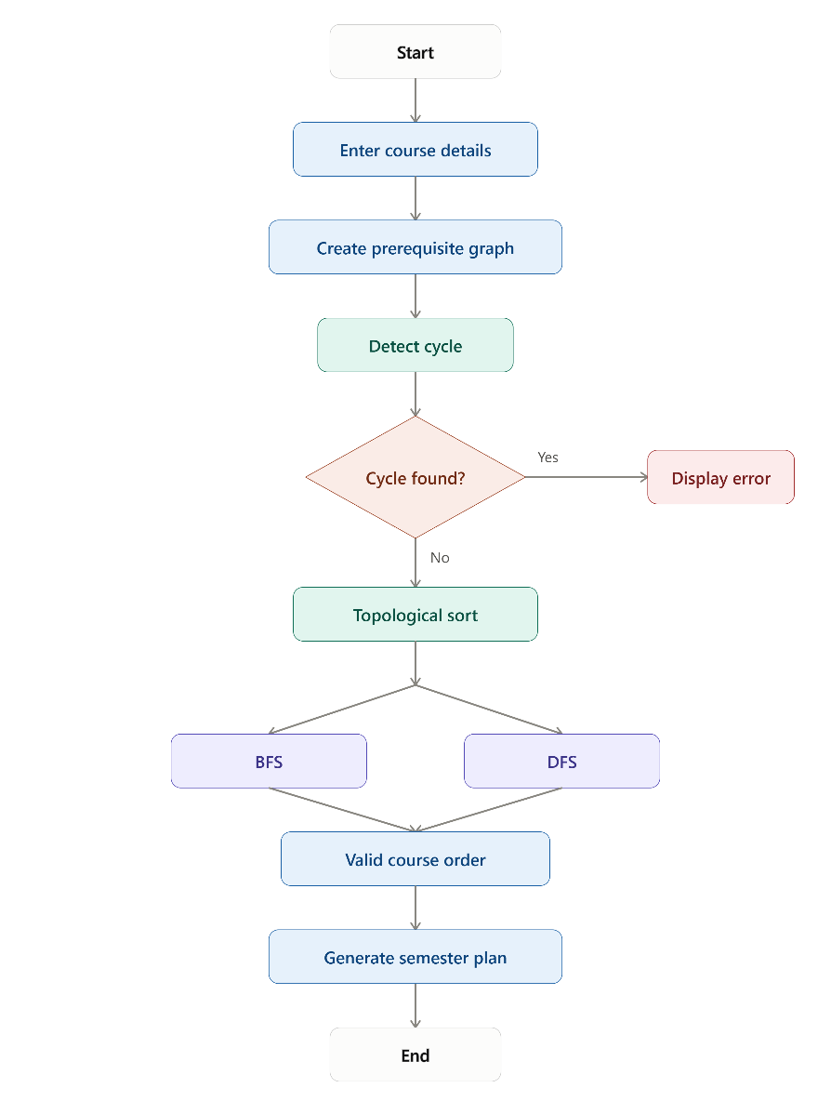

Source Code
#include <stdio.h>
#define MAX 10
int graph[MAX][MAX];
int indegree[MAX];
int state[MAX];
int stack[MAX];
int top = -1;
int dfs(int u, int n)
{
state[u] = 1
for (int v = 0; v < n; v++)
{
if (graph[u][v] == 1)
{
if (state[v] == 1)
return 0;
if (state[v] == 0)
{
if (!dfs(v, n))
return 0;
}
}
}
state[u] = 2;
stack[++top] = u;
return 1;
}
void dfsTopologicalSort(int n)
{
for (int i = 0; i < n; i++)
state[i] = 0;
top = -1;
for (int i = 0; i < n; i++)
{
if (state[i] == 0)
{
if (!dfs(i, n))
{
printf("Cycle detected using DFS.\n");
return;
}
}
}
printf("DFS Topological Order:\n");

while (top >= 0)
printf("%d ", stack[top--]);
printf("\n");
}
void bfsTopologicalSort(int n)
{
int queue[MAX];
int front = 0, rear = 0;
int result[MAX];
int count = 0;
for (int i = 0; i < n; i++)
{
if (indegree[i] == 0)
queue[rear++] = i;
}
while (front < rear)
{
int u = queue[front++];
result[count++] = u;
for (int v = 0; v < n; v++)
{
if (graph[u][v] == 1)
{
indegree[v]--;
if (indegree[v] == 0)
queue[rear++] = v;
}
}
}

if (count != n)
{
printf("Cycle detected using BFS.\n"); }
else
{
printf("BFS Topological Order:\n");

for (int i = 0; i < count; i++)
printf("%d ", result[i]);
printf("\n");
}
}
int main()
{
int n = 7;
/*
0 - C Programming
1 - Data Structures
2 - Algorithms
3 - Operating Systems
4 - DBMS
5 - Computer Networks
6 - Machine Learning
*/

graph[0][1] = 1;
graph[1][2] = 1;
graph[1][3] = 1;
graph[1][4] = 1;
graph[2][6] = 1;
graph[3][5] = 1;
graph[4][6] = 1;
for (int i = 0; i < n; i++)
{
indegree[i] = 0;
for (int j = 0; j < n; j++)
{
if (graph[i][j] == 1)
indegree[j]++;
}
}
bfsTopologicalSort(n);
dfsTopologicalSort(n);
return 0;
}

Test Cases and Expected/Actual Results
Test Case | Input Condition | Expected Result | Actual Result
TC01 | Valid prerequisite graph | Generate valid course order | Pass
TC02 | Graph contains a cycle | Display cycle detected | Pass
TC03 | Course with no prerequisite | Course appears first/available | Pass
TC04 | Multiple independent courses | Any valid ordering is accepted | Pass
TC05 | Course has multiple prerequisites | Course appears only after prerequisites | Pass
TC06 | All courses form a valid DAG | Complete topological order generated | Pass

Test Case 1 – Valid Graph
Input relationships:
C Programming → Data Structures
Data Structures → Algorithms
Data Structures → DBMS
Algorithms → Machine Learning
DBMS → Machine Learning
Operating Systems → Computer Networks
Expected:
Valid Topological Order
BFS Topological Order: 0 1 2 3 4 5 6
This course prerequisite system illustrates the use of graph algorithms to solve a real-world university scheduling problem.

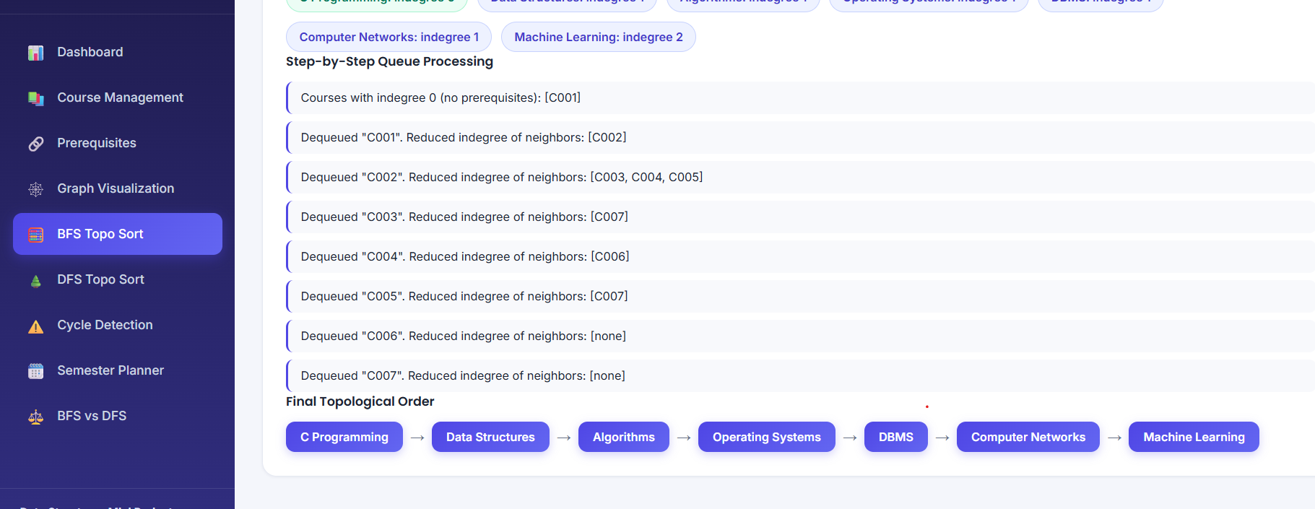
The graph is made up of vertices which represent courses, and directed edges which represent prerequisite relations. Topological sorting guarantees every prerequisite course will be listed before the course it is required in.
The time complexity of both BFS and DFS is the same, both are O(n).
Space Complexity = O(V + E)
Courses V represents the number of courses and E represents the number of relationships between courses.
They also have space complexity of:
Space Complexity = O(V + E)
If an adjacency-list representation is used.
7. Broader Considerations
7.1 Safety
The system helps identify and prioritize critical software bugs that may affect system reliability and user safety. By ensuring that high-priority issues are addressed first, it can reduce the risk of software failures.
7.2 Society
Efficient bug tracking improves the quality and reliability of software applications used by people in various sectors. Better software management can provide users with more stable and dependable digital services.
7.3 Environment
The system is a software-based solution that reduces the need for manual documentation and paper-based bug reporting. Efficient digital management can support a more organized and resource-efficient development process.
7.4 Economics
Effective bug prioritization can reduce the time and effort required to identify and resolve software issues. This can improve developer productivity, reduce maintenance costs, and minimize operational inefficiencies.
7.5 Professional Responsibility
Software developers and administrators must ensure that reported bugs are handled responsibly and accurately. A real-world bug tracking system should provide proper data security, reliable issue management, regular testing, and appropriate access control to maintain software quality and user trust.

Conclusion
The proposed University Course Prerequisite Management System is the application of the graph data and Topological Sorting.
Courses are represented by vertices, and the prerequisite relationships are represented by directed edges. For both BFS-based Kahn's Algorithm and DFS-based Topological Sort, you can get valid ordering of courses and identify cycles.
The system is also extended to illustrate the possibility of extending the topological ordering to a semester-wise planning system. A cycle in the prerequisite graph means the curriculum is not valid, and should be identified before enrollment in courses.
Both BFS and DFS have O(V + E) time complexity. But course registration and planning of a term are better suited for Kahn's BFS algorithm as it is able to directly come up with courses whose prerequisites have been fulfilled.
Student Reflection
Through this assignment, I learned how theoretical concepts from Data Structures can be applied to a practical software engineering problem. I gained a better understanding of bug management, priority-based processing, and the implementation of a Circular Priority Queue for organizing software bugs according to their importance.
I also learned that selecting an appropriate data structure depends on the requirements of the problem. In this project, the Circular Priority Queue helps ensure that critical and high-priority bugs are handled before lower-priority issues. Implementing the bug tracking system helped me understand how data structures can improve efficiency in real-world applications.
Another important learning outcome was understanding how a graphical user interface can be combined with data structures and algorithms to create an interactive and user-friendly application. Overall, this assignment improved my programming, problem-solving, and software development skills.

References
[1] T. H. Cormen, C. E. Leiserson, R. L. Rivest, and C. Stein, Introduction to Algorithms, 4th ed. Cambridge, MA, USA: MIT Press, 2022.
[2] E. Horowitz, S. Sahni, and S. Anderson-Freed, Fundamentals of Data Structures in C. New York, NY, USA: Computer Science Press, 1993.
[3] R. Thareja, Data Structures Using C, 2nd ed. New Delhi, India: Oxford University Press, 2014.
[4] M. A. Weiss, Data Structures and Algorithm Analysis in C, 2nd ed. Boston, MA, USA: Addison-Wesley, 1997.
[5] A. V. Aho, J. E. Hopcroft, and J. D. Ullman, Data Structures and Algorithms. Reading, MA, USA: Addison-Wesley, 1983.
[6] I. Sommerville, Software Engineering, 10th ed. Boston, MA, USA: Pearson, 2016.
[7] R. S. Pressman and B. R. Maxim, Software Engineering: A Practitioner's Approach, 9th ed. New York, NY, USA: McGraw-Hill Education, 2019.
[8] S. McConnell, Code Complete: A Practical Handbook of Software Construction, 2nd ed. Redmond, WA, USA: Microsoft Press, 2004.
[9] R. S. Pressman, Software Engineering: A Practitioner's Approach, 8th ed. New York, NY, USA: McGraw-Hill Education, 2014.
[10] Department of Computer Science and Engineering, CSA03 – Data Structures: Course Notes and Laboratory Materials, 2026.

Project Title: Smart Software Bug Tracking and Issue Management System for Efficient Bug Prioritization and Resolution
Group Members: Deepika. P ,Sharmila .M, Nivedhitha. G , S Susmitha.
Individual Reflection
Working on the topic “Smart Software Bug Tracking and Issue Management System for Efficient Bug Prioritization and Resolution” helped me understand how Data Structures can be applied to solve practical problems in software development and maintenance. Before working on this project, I mainly understood concepts such as queues and priority queues as theoretical data structures. Through this project, I learned how these concepts can be used to efficiently organize and manage software bugs based on their importance and priority.
One of the most important concepts I learned was the implementation of a Circular Priority Queue. I understood how bugs with different priority levels, such as Critical, High, Medium, and Low, can be organized so that important issues are handled before less critical ones. This helped me understand how appropriate data structures can improve the efficiency of real-world applications.
While working on this project, I improved my understanding of bug tracking, priority-based processing, queue operations, and algorithmic problem-solving. I also learned that selecting the correct data structure depends on the requirements of the problem. The Circular Priority Queue was particularly useful in managing multiple bugs efficiently while maintaining their priority order..
Working on the application also improved my programming and problem-solving skills. I gained experience in connecting Data Structure concepts with a practical application and understood how a graphical user interface can make the system more interactive and user-friendly. I also gained confidence in explaining technical concepts and demonstrating how the implemented data structure works within the application. Overall, this project was a valuable learning experience for me. I believe the logical thinking, programming, and problem-solving skills I developed through this project will be useful in my future academic projects and software development work.
Declaration
I confirm that the above represents an accurate account of my individual contribution to the design, development, and implementation of the Smart Software Bug Tracking and Issue Management System for Efficient Bug Prioritization and Resolution.
Signature: ___________________________
Name: _______________________________
PLAGRASIM: 4%
GITHUB LINK : https://github.com/deepika072/CSA0313-data-structure.git

